STRATEGIC PROJECT PROPOSAL
CuraLink EMR: Family-Centered Healthcare & Field Medicine Platform
1. Executive Summary
CuraLink EMR is an innovative, enterprise-grade healthcare platform designed to connect community-based field medicine with centralized hospital administration. The system is designed to facilitate proactive, preventative, and family-centered healthcare delivery. By leveraging a multi-channel architecture, CuraLink resolves the critical disconnect between urban clinics and remote, rural patient care.
At its core, CuraLink integrates three high-impact sub-systems:
- Offline-First Mobile App: – Designed for doctors, nurses, and field health workers to log clinical history, manage families, and run home care operations entirely offline.
- Centralized Cloud Hub: – Exposes advanced analytics, administrative controls, and system-wide audit logging to clinical operators, directors, and billing staff.
- Self-Service Family Portal: – Allows households to request visits, message their primary doctor, check billing status, and pay subscriptions via mobile money channels.
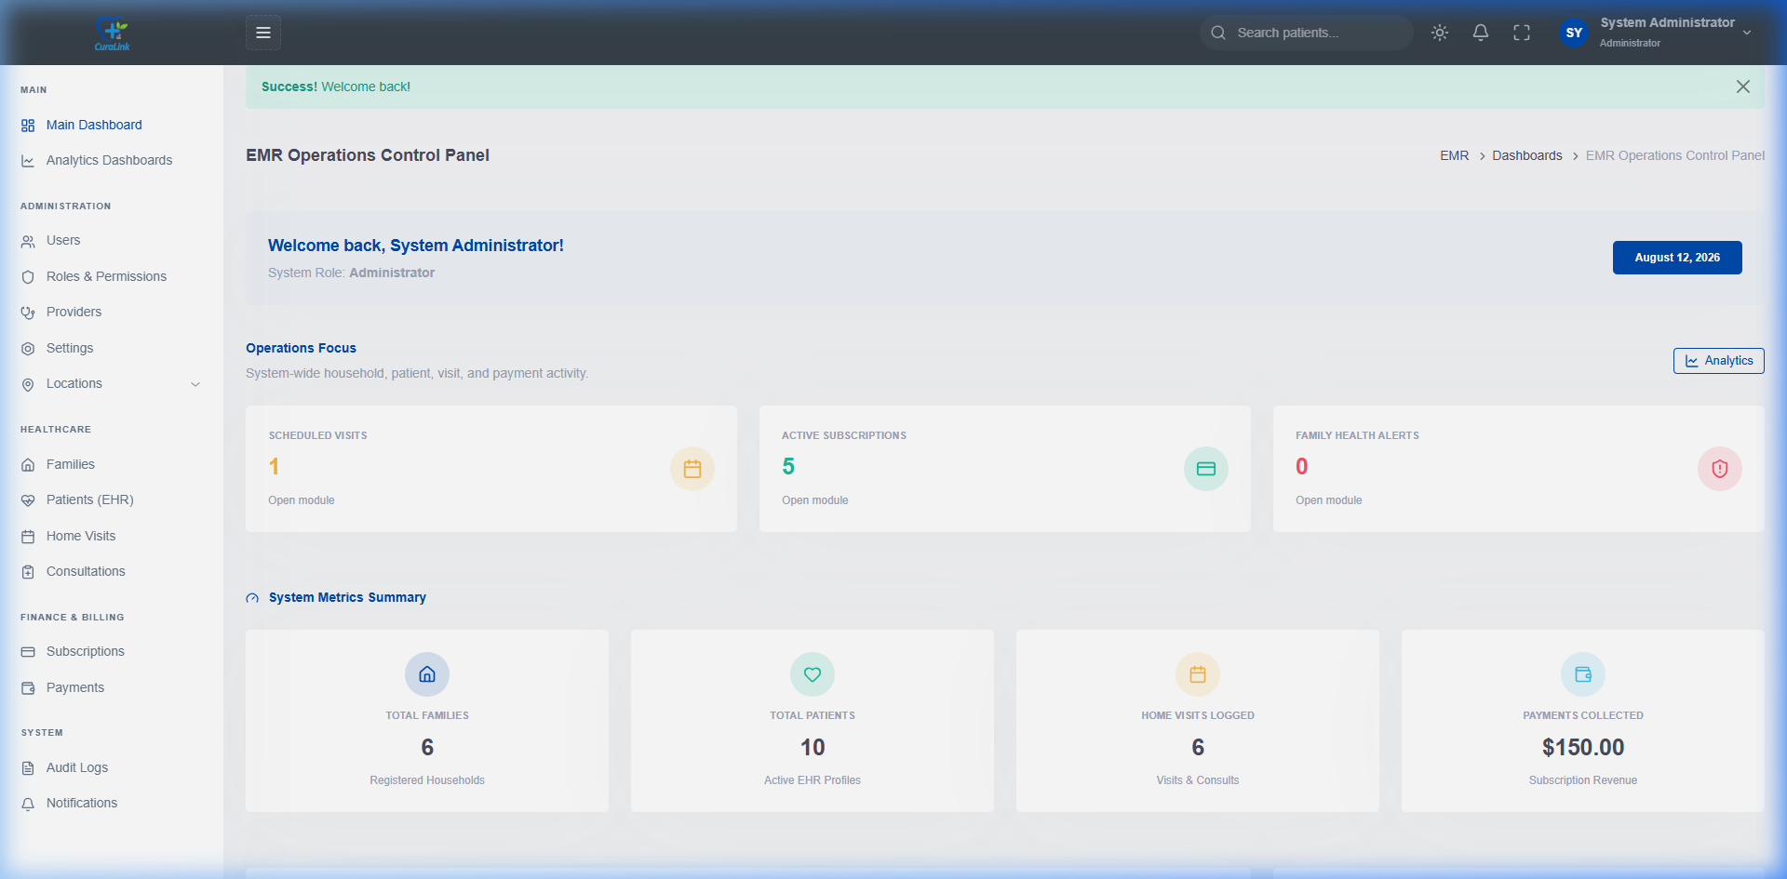
Figure 1: Administrator Dashboard - Operational overview of registered families, doctors, clinics, and geographic coverage.
2. Strategic Value Proposition for Investors & Partners
For corporate partners, healthcare networks, and impact investors, CuraLink presents a unique, sustainable, and highly scalable investment opportunity:
- Actionable Health Intelligence: By focusing on families as a single unit and tracking social determinants (housing, sanitation, water), CuraLink enables healthcare networks to perform preventative interventions before chronic diseases escalate, reducing total hospital load.
- Infinite Scalability by Design: Built on a standardized, hierarchical geographic mapping system, CuraLink can be rapidly adapted and deployed to any district, region, or country.
- Sustainable Financial Revenue: Integrated subscription engines and direct mobile money channels (MTN, Airtel, Zamtel) enable healthcare networks to maintain a self-sustaining funding loop, ensuring long-term operational viability without perpetual donor dependency.
- Enterprise Compliance and Governance: Features built-in, automated auditing of all clinical edits and user sessions to meet strict national healthcare compliance and data-integrity regulations.
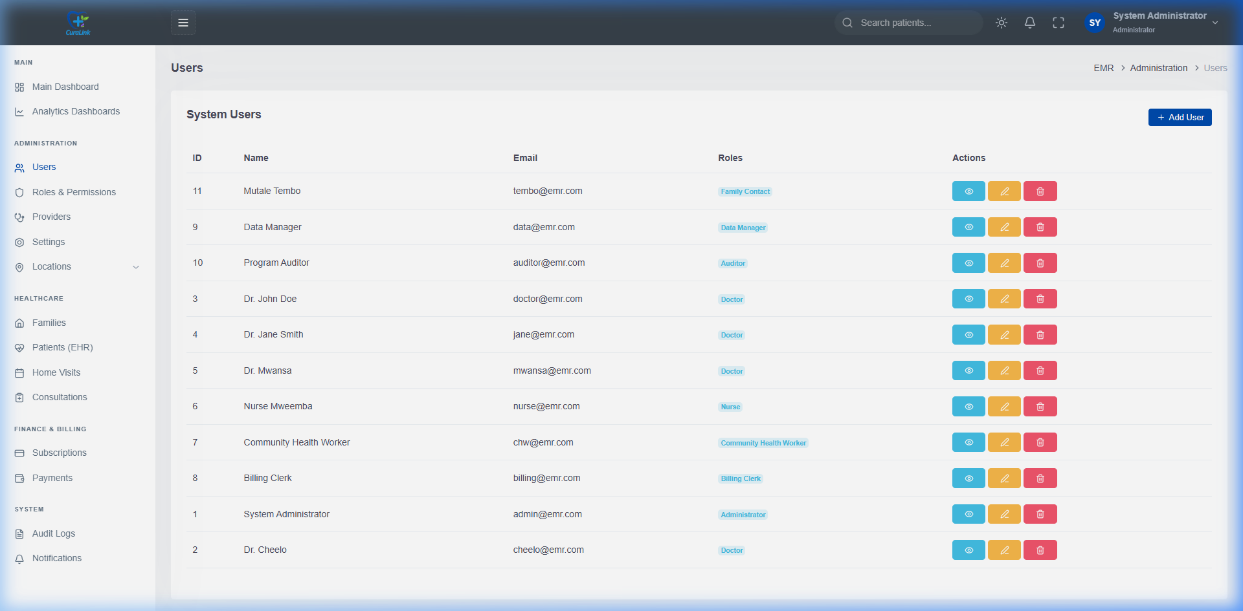
Figure 2: User Role Allocation - Shows how the system maps credentials and access control for administrators, medical directors, doctors, and staff.
3. Core Innovation: Dynamic Family Health Risk Scoring
A key breakthrough of the CuraLink platform is its dynamic, automated Family Health Risk Scoring engine. Rather than assessing patient files in isolation, the system evaluates the entire household. Whenever a patient file or household environment metric is updated, the server instantly recalculates the Family Health Score (0 to 100) and updates the household's risk classification.
The scoring criteria includes:
- Disease Burden (Max 30 pts): Adds 10 points for each member with a chronic condition and 20 points for each member with a disability.
- Vulnerable Ages (Max 20 pts): Adds 10 points for children under 5 and 10 points for elderly members over 60.
- Social Determinants (Max 20 pts): Adds 5 points for each adverse indicator: mud-walled housing, unprotected water sources, pit latrines, lack of electricity, or informal land tenure.
- Lifestyle Risks (Max 15 pts): Adds up to 15 points for smoking, alcohol use, or sedentary lifestyles inside the household.
- Mental & Social Risks (Max 15 pts): Evaluates domestic risks, social isolation, and financial stress.
Operational Care Priority Path
These risk classifications dictate the dispatch schedule for doctors and field health teams, optimizing medical resource allocation:
- Green (Low Risk: 0-25): Routine annual health screening and wellness check-ups.
- Yellow (Moderate Risk: 26-50): Bi-annual check-ups and targeted health education.
- Orange (High Risk: 51-75): Quarterly visits and coordinated care management.
- Red (Very High Risk: 76-100): Priority monthly home clinical intervention and active follow-up.
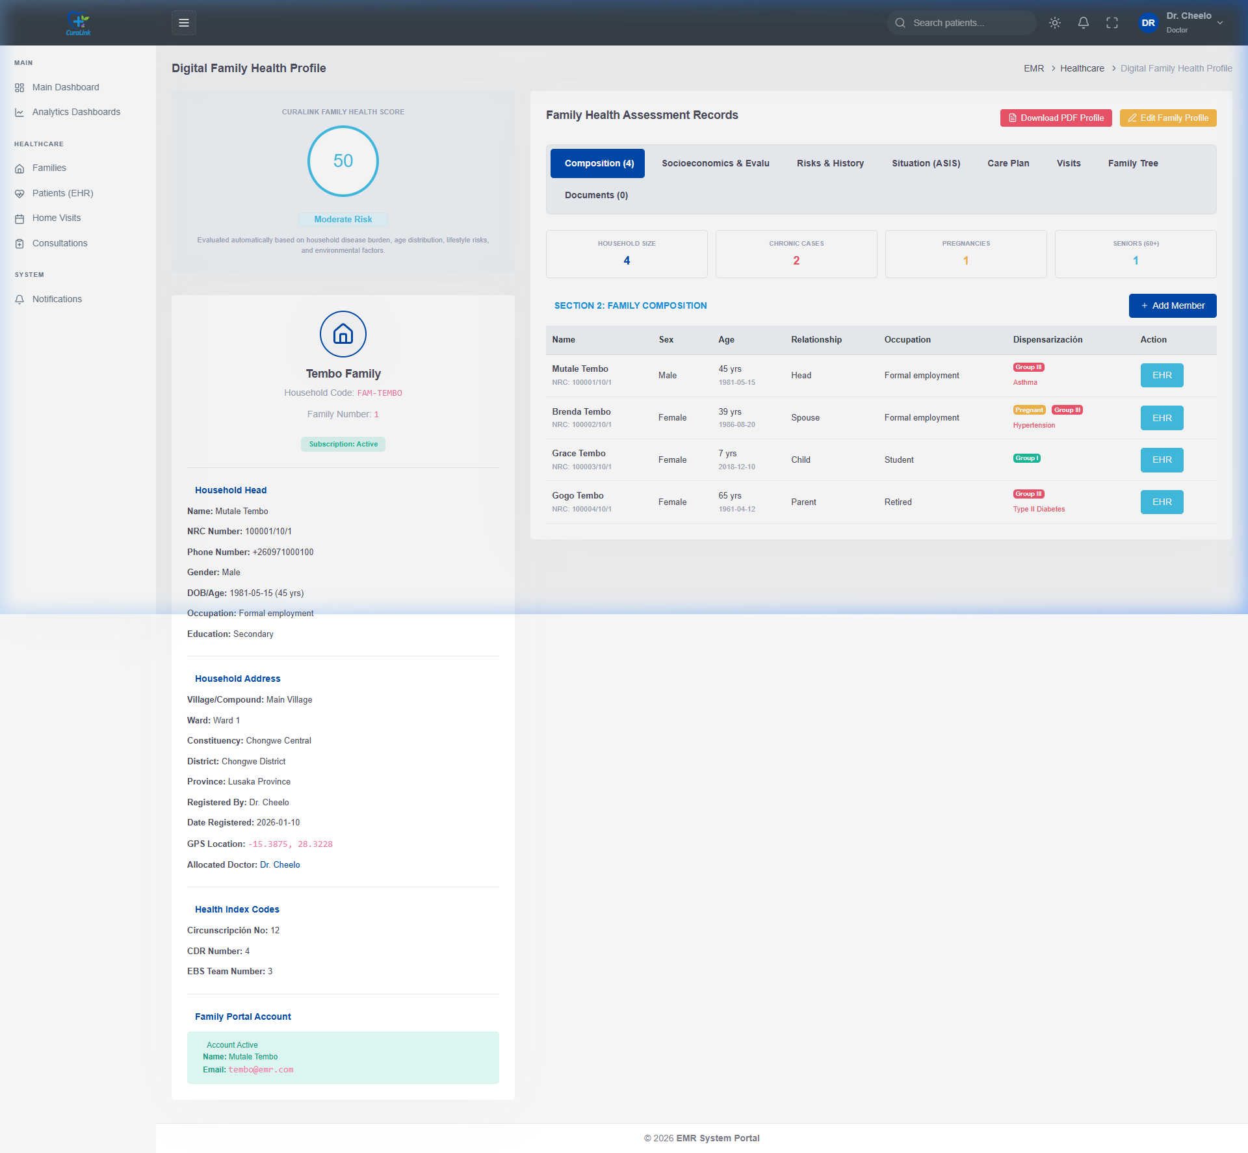
Figure 3: Household Detail & Health Risk Score - Tracks environment, water source, and automatically rates the Tembo family as Moderate Risk (Score: 50).
4. Technical Infrastructure & Data Integrity
Investors can be confident in the platform's robust, enterprise-grade architecture. CuraLink is built using cutting-edge, secure frameworks:
- Cloud Backend: Powered by Laravel 13 utilizing PHP 8.4, with SQLite/MySQL databases and Laravel Sanctum for secure token-based mobile app authentication.
- Mobile App: Developed in Flutter (Dart) using Drift reactive database driver, creating a fully functional offline local database.
- Offline Sync Protocol: To prevent primary key collisions when inserting records offline, the system uses globally unique UUIDv4 keys generated locally. Changes are tracked via 'isDirty' and 'isDeleted' flags, and resolved bidirectionally upon syncing.
- Compliance & Audit Trail: Utilizes a database-level observer to record all creation, deletion, and update events, capturing the user, timestamp, original data, mutated data, and client User-Agent.
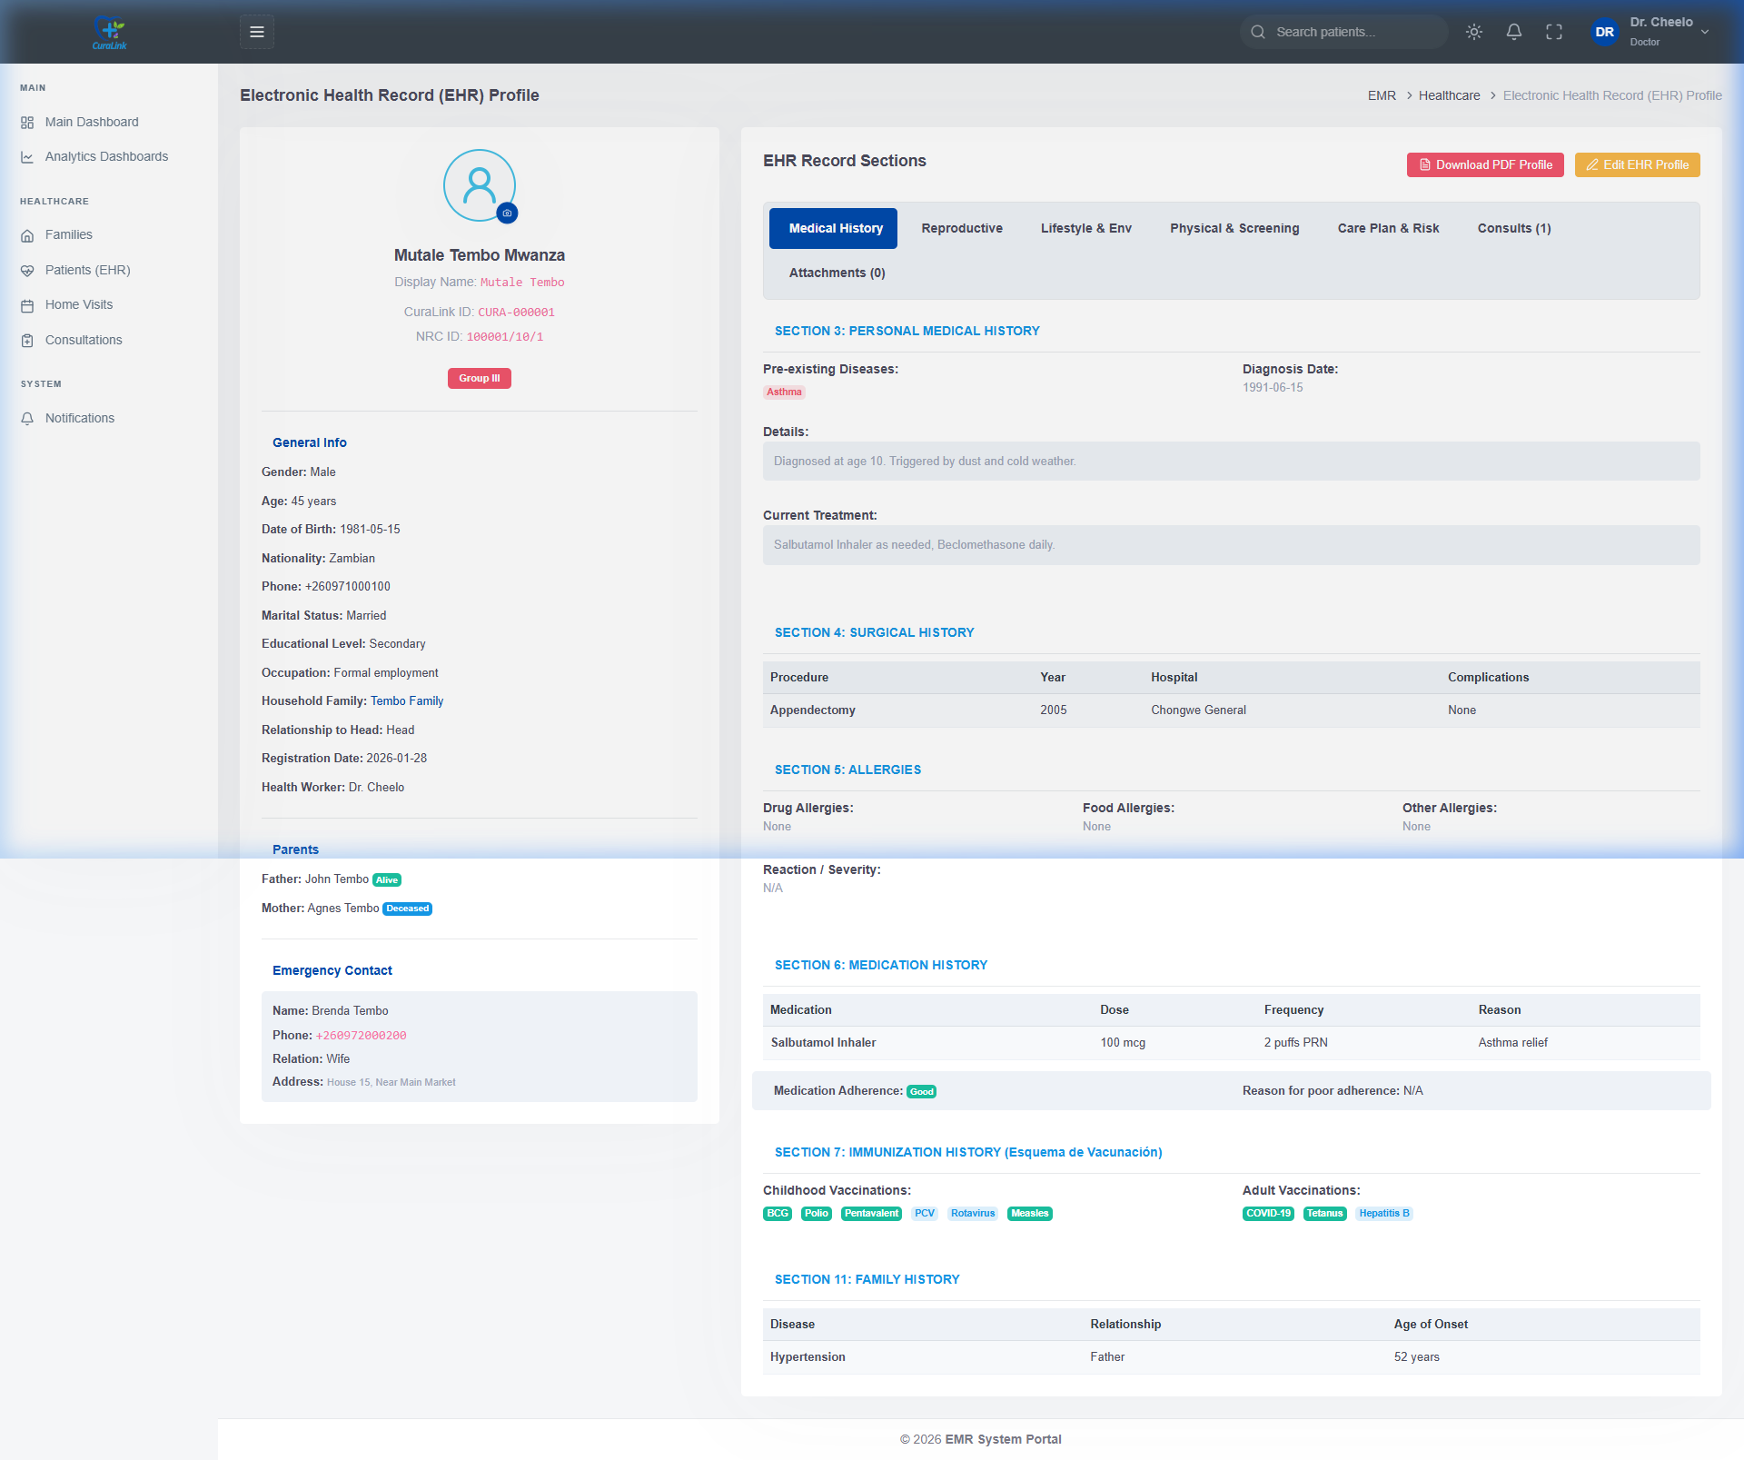
Figure 4: 16-Section Patient Health Profile - Standardized clinical intake form covering medical, surgical, and lifestyle histories for patients like Mutale Tembo.
5. Integrated Financial Model & Billing
Sustainable funding is critical for corporate partnerships. CuraLink integrates a robust billing module that tracks payments and manages family subscriptions. The dashboard aggregates data from mobile money providers (such as MTN, Airtel, and Zamtel), showing transactions, balances, and subscription periods.
Key billing functionalities include:
- Mobile Money Ledger: Allows the billing department to reconcile incoming transaction codes with registered family subscriptions.
- Subscription Control: Tracks subscription start dates, renewal dates, and payment status, automatically flagging lapsed households.
- Financial Reporting: Generates transaction histories and exportable financial sheets for audits and leadership review.
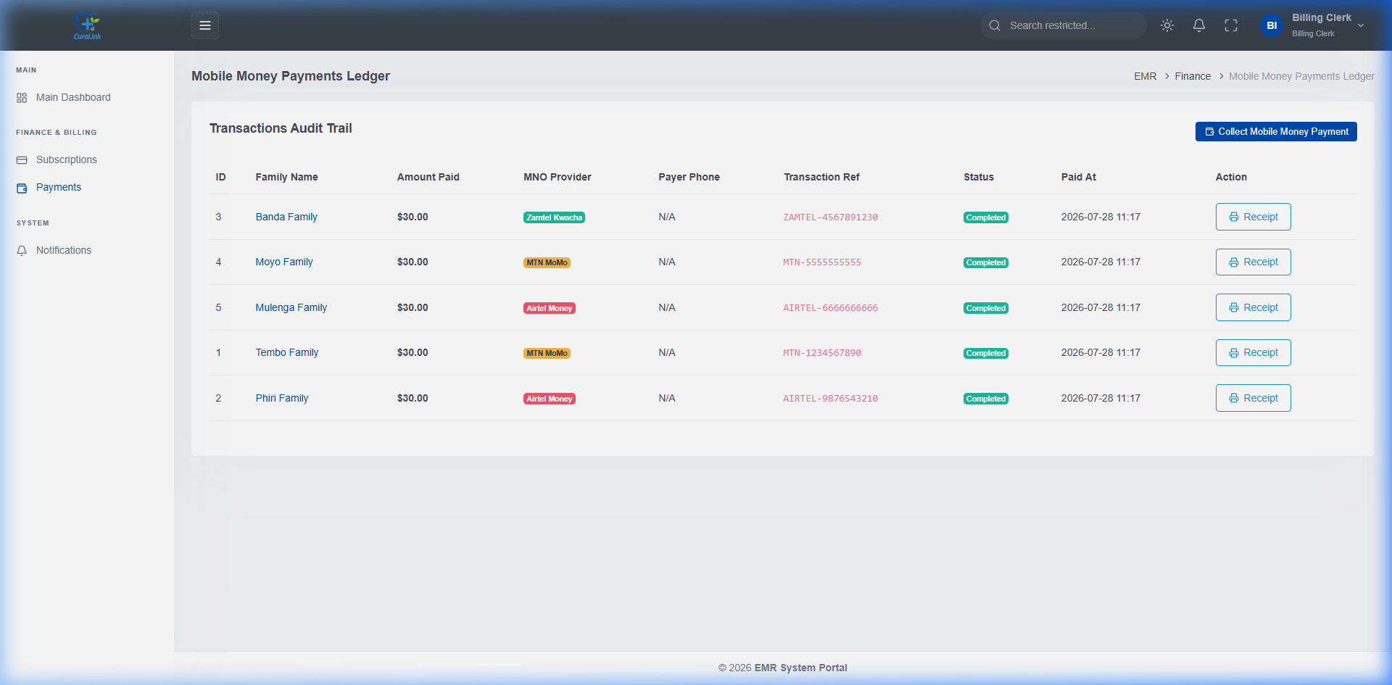
Figure 5: Payments & Subscriptions Ledger - Reconciles transactions from mobile money providers (MTN, Airtel, Zamtel) directly to subscription timelines.

